**FLEET APP version 1.5 concerns**

LOGISTICS HEAD

1. Create Order
2. New SO / New PO / New ITR nudges. Why all of them have transaction numbers already?

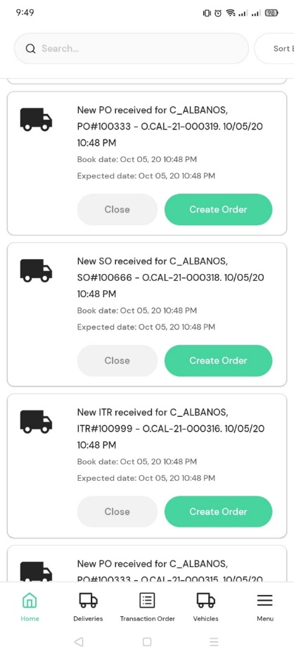

1. Why after transaction order creation goes directly to create delivery immediately?
2. How to add multiple transactions in one delivery?
3. Transaction order -> In Process

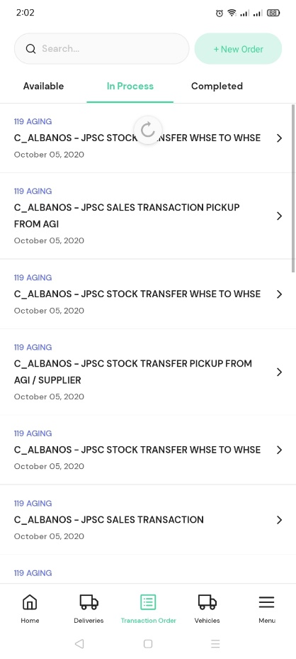

Instead of this date, show the assigned delivery date, sorted from the earliest to latest

1. Delivery Details – destination poi not matched.

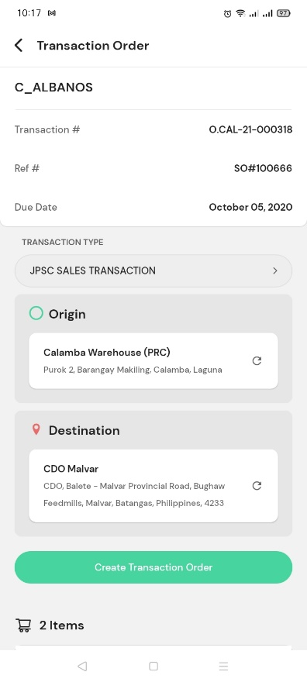

My created order

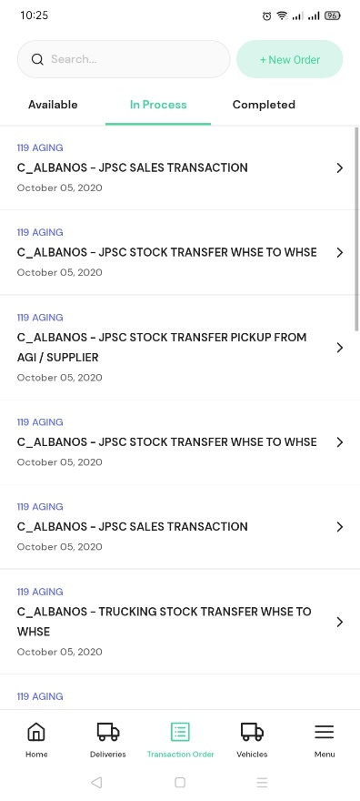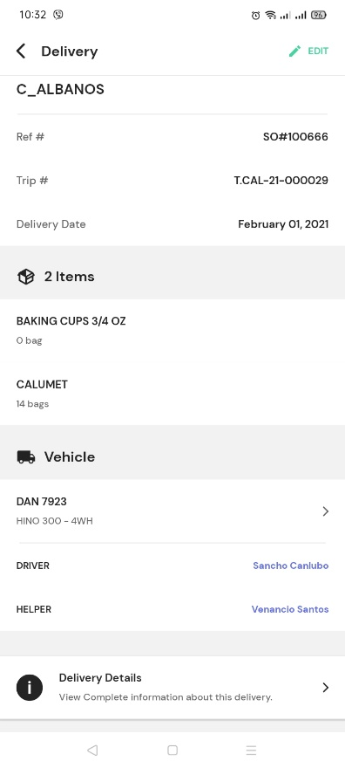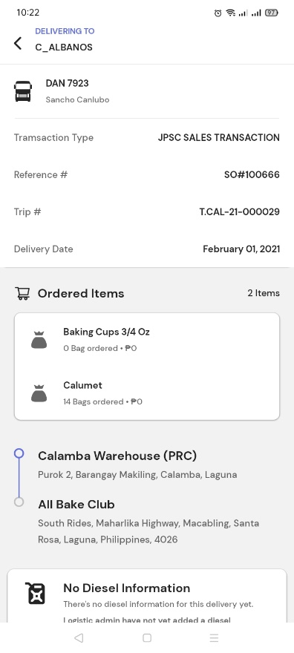

In process -> Delivery details

X

1. Destination POI is different every time I click the trip.

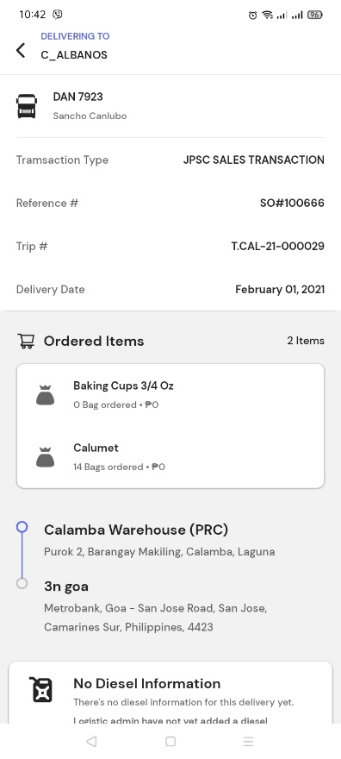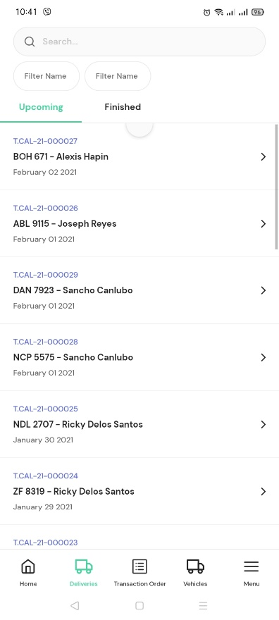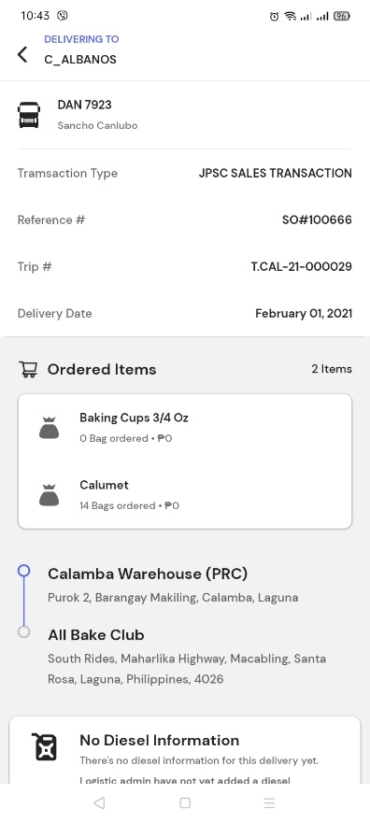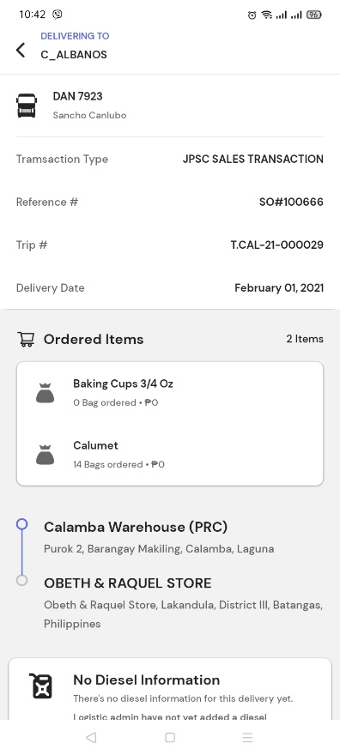

Deliveries

1st click

2nd click

3rd click

X

X

X

1. Add another selection of warehouse.

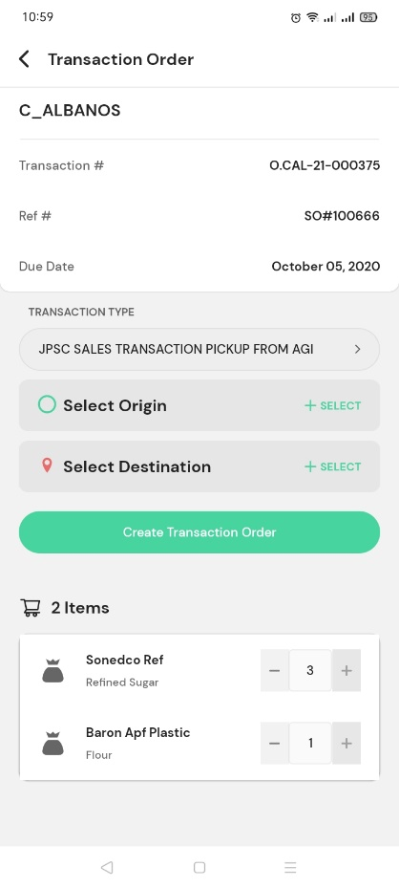

Can you make it like this?

Show all of these, whatever the transaction type is.

=**Select Origin** - the jpoon warehouse where the inspection of truck, issuance of diesel PO, releasing of documents and petty cash will be processed.

=**Select Pick-up Stocks from** - warehouse where the stocks will be pick-up.

=**Select Destination** – POI of the recipient.

1. I can create a transaction order even if the total of items is zero. This should not be.

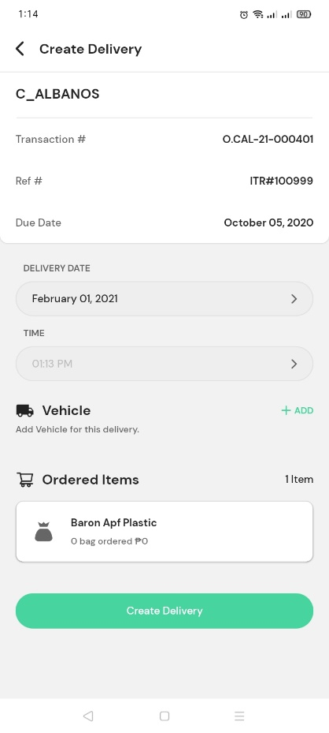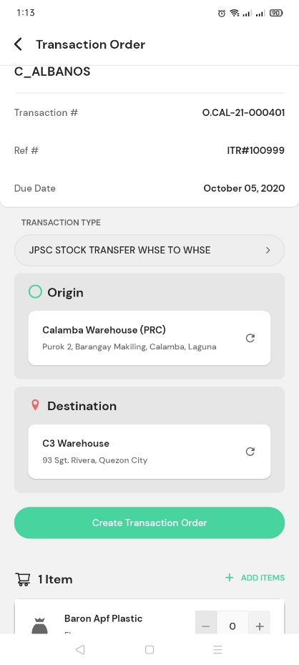

1. Accidentally selected a wrong Delivery date, I want to select the date today but I can’t select the date today.

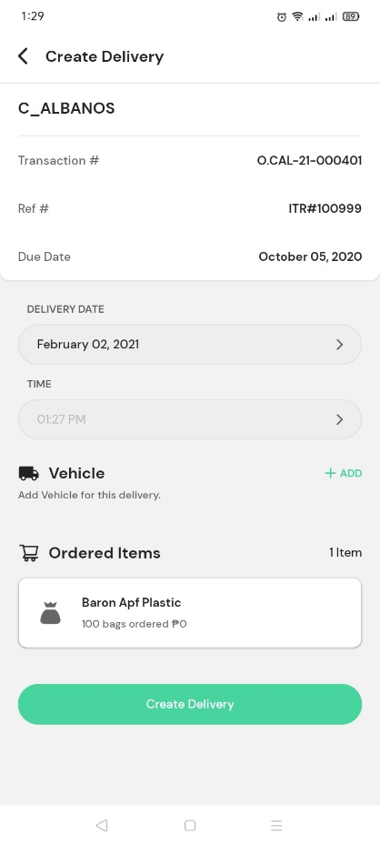

1. Set time earlier than the time of creation is not allowed.
2. I can assign a Customer Truck even if the transaction type is JPSC. This should not be.

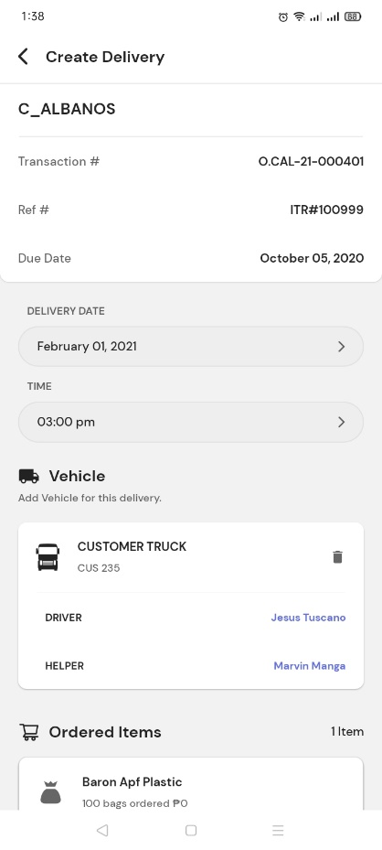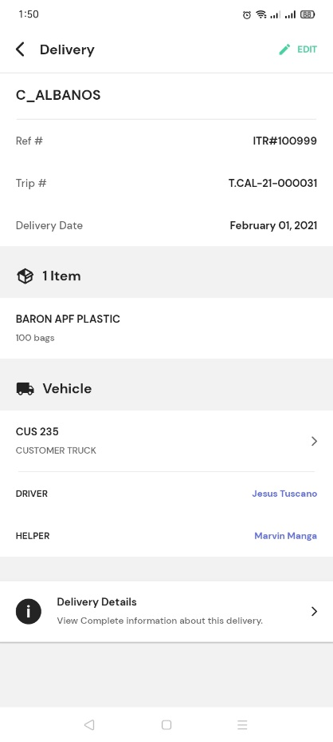

1. After the delivery creation, where can I find the transaction#?



1. Allow us to change the recipient in creating transaction order for PO. or can you leave it blank on the nudge, so that we can just select the recipient manually? Because there is no CardCode field in PO.

